EXPERIMENT – 6

NAME: RAHUL GOEL

Reg no:RA1911030010094

AIM: Multiplying two 8 bit numbers.

Software used: EMU8086

Coding :

data segment

A db 09h

B db 02h

Res 1 dw ?

data ends

code segment

assume cs: code, ds: data

start:

mov ax, data

mov ds,ax

mov al,a

mov bl,b

mul b

mov Res 1,ax

int 3

code ends

end start

Coding in EMU8086:

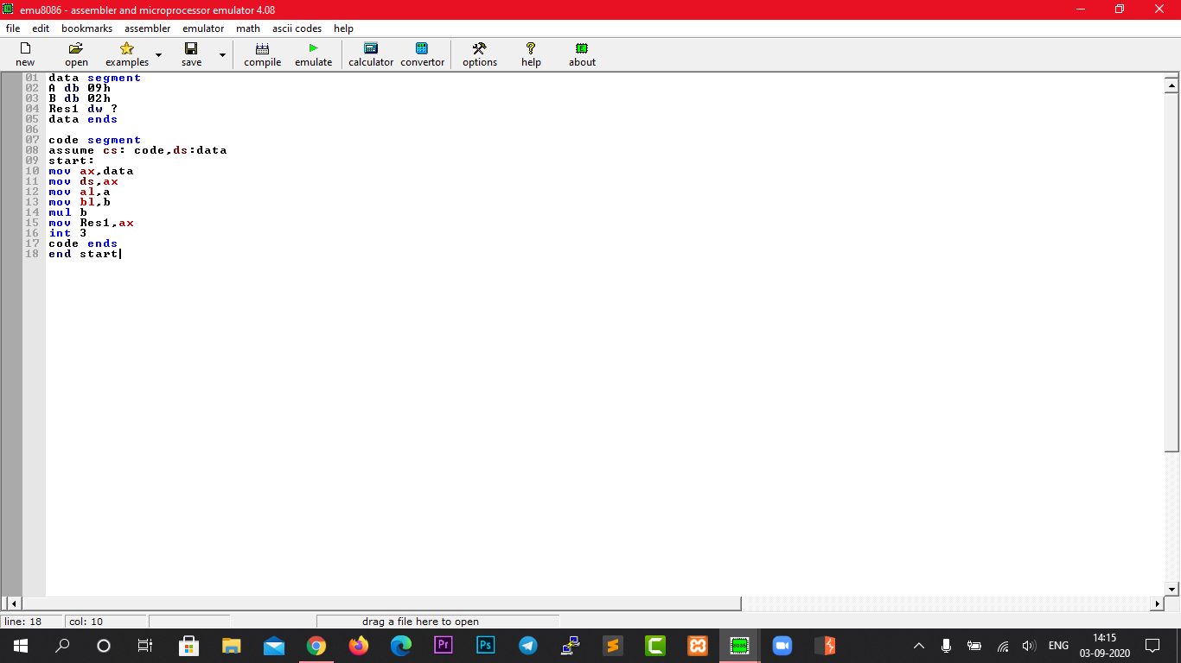

Output in EMU8086:

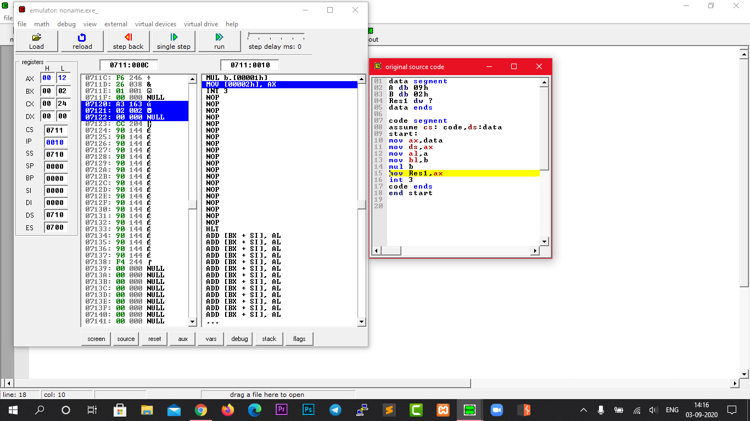

AX value as 12

Result:

The Multiplication of 8-bit numbers have been done using the emulator.